COMP30660 - Computer Arch & Org (Conv) -2022/23 Tutorial 3

1. Sort these four strings based on their ASCII representations:

a. Manchester 77 97 110 99 104 101 115 116 101 114

b. manchester 109 97 110 99 104 101 115 116 101 114

c. Mancester 77 97 110 99 101 115 116 101 114

d. !Mancester 33 77 97 110 99 101 115 116 101 114

d < c < a < b

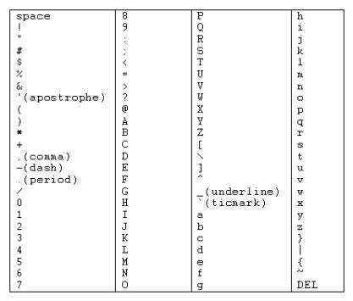

*ASCII* *Sort* *Order* *Chart*

1. What is the following word which is represented in ASCII? Refer an ASCII table 68 117 98 108 105 110

Dublin

3. How many bytes (exactly) in

a. 4kB 4096

b. 32MB 33554432

4. How many characters can be represented (in theory) in UTF-32?

2^32 distinct characters

5. Draw the signalling diagram for the following bit representation

1100010111011001

a. NRZ coding --___-_---_--__-

b. NRZI coding

c. Manchester coding

6. What is redundancy in error checking in a transmission?

Adding extra bits for detecting error at the destination

7. What would be the value of X if the byte X1001101 is transmitted using even parity? X = 0

8. Express 12.37510 in the revised 14-bit floating point model. Use 16 as bias

0 10100 11000110

1. Approximately how many pages of pure 16-bit Unicode text can a 4GB USB key hold?

There is clear ambiguity contained in this question (characteristic of the real world!) which requires you to set out a reasonable and defensible hypothesis for how many characters are contained in a page. **Outline** **and** **explain** **your** **assumptions.**

10. Eircode - the Irish Postal Code system

An Eircode is a seven character alpha-numeric code made up of two parts.

The first part (**a** **Routing** **Key**) consists of three characters and defines a principal post town span of delivery. The second part (**a** **Unique** **Identifier**) is unique to an address and distinguishes one address from another. A sample Eircode might read A45 F4E2. To avoid confusion, certain letters that might be ambiguous like the letter 'O' are not included.

Assuming the Routing Key is always a letter followed by two decimal digits and the Unique Identifier is always a letter followed by three characters that can be numbers or letters, and disregarding the exception case provided here (D6W)

Calculate,

● How many possible Unique Identifiers? 234.375

● How many possible Eircode addresses are there? 351.562.500

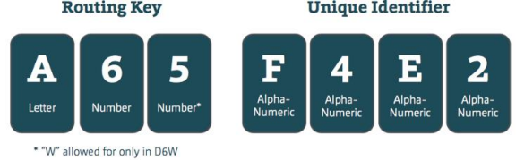

|  |  |  |
| --- | --- | --- |
| Component | Position | Allowed Characters |
| Routing Key | 1 | A,C,D,E,F,H,K,N,P,R,T,V,W,X,Y |
| 2 | 0-9 |
| 3 |
| Unique Identifier | 4 | A,C,D,E,F,H,K,N,P,R,T,V,W,X,Y |

|  |  |  |
| --- | --- | --- |
|  | 5 | 0-9 and A,C,D,E,F,H,K,N,P,R,T,V,W,X,Y |
| 6 |
| 7 |